Abstract Noun

🔹 What is Abstract Noun
# Source: AI Source: Provided by: [Data Path: Persons Table -> ID Column: 1, Name_En Column: Motasem Essam] -> From: [Chatgpt (GPT-4-turbo)] on [7/26/2025]
An abstract noun is a noun that refers to something you cannot see, touch, hear, smell, or taste.
🧠 It names ideas, feelings, qualities, or states — things that exist in the mind, not the physical world.

✅ Definition:
# Source: AI Source: Provided by: [Data Path: Persons Table -> ID Column: 1, Name_En Column: Motasem Essam] -> From: [Chatgpt (GPT-4-turbo)] on [7/26/2025]
An abstract noun is a noun that refers to something intangible — you can’t detect it with your five senses, but you can understand or feel it.

🧠 Examples of Abstract Nouns:
# Source: AI Source: Provided by: [Data Path: Persons Table -> ID Column: 1, Name_En Column: Motasem Essam] -> From: [Chatgpt (GPT-4-turbo)] on [7/26/2025]
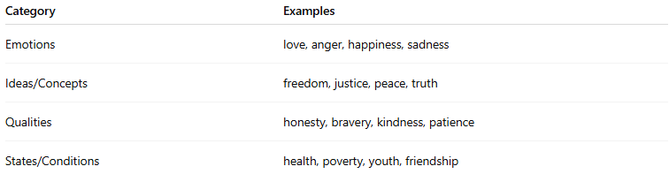
Category | Examples
Emotions | love, anger, happiness, sadness
Ideas/Concepts | freedom, justice, peace, truth
Qualities | honesty, bravery, kindness, patience
States/Conditions | health, poverty, youth, friendship

📝 Example Sentences:
# Source: AI Source: Provided by: [Data Path: Persons Table -> ID Column: 1, Name_En Column: Motasem Essam] -> From: [Chatgpt (GPT-4-turbo)] on [7/26/2025]
- Love is more powerful than hate. ❤️
- She values honesty above all.
- Freedom is a basic human right.
- His kindness touched everyone’s heart.

🔄 Opposite: Concrete Nouns
# Source: AI Source: Provided by: [Data Path: Persons Table -> ID Column: 1, Name_En Column: Motasem Essam] -> From: [Chatgpt (GPT-4-turbo)] on [7/26/2025]
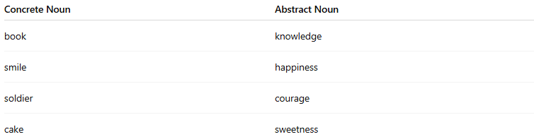
Concrete Noun | Abstract Noun
book | knowledge
smile | happiness
soldier | courage
cake | sweetness

📘 Concrete Nouns vs. Abstract Nouns
# Source: AI Source: Provided by: [Data Path: Persons Table -> ID Column: 1, Name_En Column: Motasem Essam] -> From: [Chatgpt (GPT-4-turbo)] on [7/26/2025]
Both concrete and abstract nouns are types of common nouns, but they describe very different kinds of things.

🔹 1. Concrete Nouns
# Source: AI Source: Provided by: [Data Path: Persons Table -> ID Column: 1, Name_En Column: Motasem Essam] -> From: [Chatgpt (GPT-4-turbo)] on [7/26/2025]
- Refer to physical things you can see, touch, hear, smell, or taste
- Have a physical form
Examples:
- cat, table, perfume, music, water, baby
🧠 You can sense them with your body.

🔹 2. Abstract Nouns
# Source: AI Source: Provided by: [Data Path: Persons Table -> ID Column: 1, Name_En Column: Motasem Essam] -> From: [Chatgpt (GPT-4-turbo)] on [7/26/2025]
- Refer to ideas, feelings, or qualities that cannot be sensed physically
- Exist in the mind or as a concept
Examples:
- love, beauty, freedom, truth, fear, knowledge
🧠 You can feel or understand them, but not see or touch them.

🧠 Key Differences Table:
# Source: AI Source: Provided by: [Data Path: Persons Table -> ID Column: 1, Name_En Column: Motasem Essam] -> From: [Chatgpt (GPT-4-turbo)] on [7/26/2025]
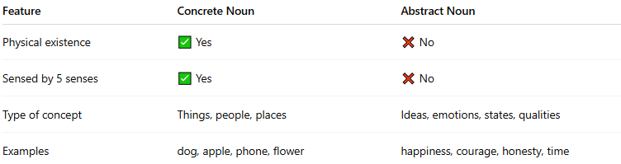
Feature | Concrete Noun | Abstract Noun
Physical existence | ✅ Yes | ❌ No
Sensed by 5 senses | ✅ Yes | ❌ No
Type of concept | Things, people, places | Ideas, emotions, states, qualities
Examples | dog, apple, phone, flower | happiness, courage, honesty, time

📝 Example Sentences:
# Source: AI Source: Provided by: [Data Path: Persons Table -> ID Column: 1, Name_En Column: Motasem Essam] -> From: [Chatgpt (GPT-4-turbo)] on [7/26/2025]
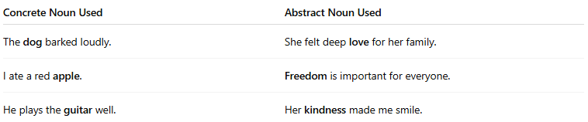
Concrete Noun Used | Abstract Noun Used
The dog barked loudly. | She felt deep love for her family.
I ate a red apple. | Freedom is important for everyone.
He plays the guitar well. | Her kindness made me smile.

✅ Tip to Remember:
# Source: AI Source: Provided by: [Data Path: Persons Table -> ID Column: 1, Name_En Column: Motasem Essam] -> From: [Chatgpt (GPT-4-turbo)] on [7/26/2025]
- If you can touch or see it ➝ Concrete
- If you can only feel or think about it ➝ Abstract

✅ Summary:
# Source: AI Source: Provided by: [Data Path: Persons Table -> ID Column: 1, Name_En Column: Motasem Essam] -> From: [Chatgpt (GPT-4-turbo)] on [7/26/2025]
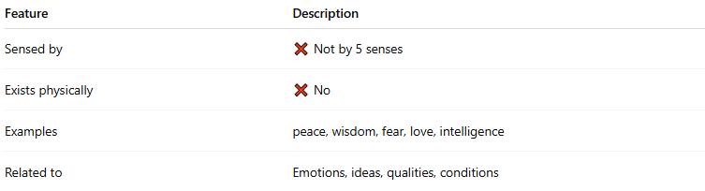
Feature | Description
Sensed by | ❌ Not by 5 senses
Exists physically | ❌ No
Examples | peace, wisdom, fear, love, intelligence
Related to | Emotions, ideas, qualities, conditions

